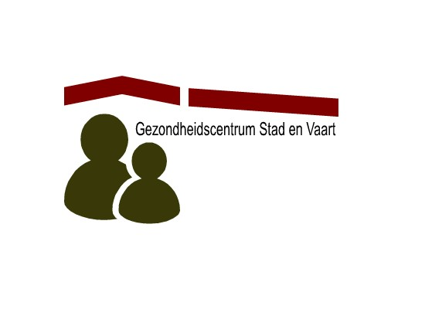
Huisartsenpraktijk Naarden
Wilhelminastraat 27
2011 VJ Haarlem
Tel: 023-5313600
www.huisartsenpraktijknaarden.nl

Huisartsenpraktijk Thoolen
Wilhelminastraat 27
2011 VJ Haarlem
Tel: 023-5315058
www.dokterthoolen.nl
Information on the Dutch Healthcare system and the GP (huisarts)

The Dutch healthcare system and the role of the GP
The GP treats patients for common and minor diseases and can answer most of your general health questions. (S)he is also able to perform minor surgery or place an IUD. The GP also performs, for example, standard gynaecological or paediatric examinations. It is normal for children to be seen by a GP as paediatricians generally only see children with special needs or conditions. The same applies to gynaecologists.

A GP has received a basic 6-year medical education and after that 3 years of specialist training. A GP is also trained to recognize a condition that require you to be seen by another health care specialist. Statistically 9 out of 10 complaints are treated by the GP and for 10% of the complaints a referral is needed. Your GP will therefore also serve as your link to most other services, such as hospitalization, specialists, home nursing, and physiotherapy.

For a referral to another medical specialist the GP will usually provide you a letter of referral to be given to the specialist. The GP can only refer you if there is a medical need for it. You may have to wait several weeks or longer for an appointment, unless the matter is urgent.
Without the referral note, your health insurance company most likely will not reimburse you. You can visit the Emergency room of the hospital without a referral, but only in emergencies. And you can visit other primary care providers, such as a midwife, physiotherapist or dentist without a referral from your GP.

Making an appointment
If you call the GP’s office to make an appointment, the GP’s assistant, will ask questions in order to:
- determine the urgency of your situation (and, in some cases, check if more immediate action is required)
- to check whom you would need to see (a GP or a practice assistant)
- to suggest alternatives, like a consultation by phone.

The GP’s assistant is a medical professional and has an obligation of confidentiality.
Blood pressure checks, making ECG's and wound treatment are examples of tasks the assistents also perform.
Women, between 30 and 65 years of age, will receive an invitation for a cervixsmear every 5 years as part of the screening offered by the government. This is performed by the assistent.
Women, between 50 and 70 years of age, will receive an invitation for a mammogram every 2 years. This performed in a special X-ray laboratorium.

A consult with a GP is generally limited to 10 minutes. If you think that you need more time with the doctor, because you have more than one complaint, you can discuss this with the GP’s assistant. The maximum duration of an appointment is 20 minutes. Of course you can schedule a second appointment if you have several complaints.

Medication
Your GP will also prescribe medication you may need. Prescriptions are filled at a pharmacy (Apotheek). You may find a difference with your home country: In the Netherlands, doctors are less likely to prescribe antibiotics and other medication compared to what you may be accustomed to.
Evidence shows that it is often best to let an illness run its course without tests and medication that may have harmful side effects. This wait-and-see approach is medically appropriate for minor illnesses such as a sore throat or a common cold.

The nearest pharmacies are:
- Benu Centraal apotheek, Gedempte oude gracht 103-105, Haarlem Tel: 023-5319148
- Klinkhamer apotheek, Koninginneweg 69, Haarlem Tel: 023-5316528
- Elan apotheek Loomeyer, Zijlweg 34, Haarlem Tel: 023-5316415
At your 1st visit to the pharmacy you will be required to register. You will need your ID and your insurance card.

Dutch Health Insurance
The Basic Dutch Health Insurance Policy (Basisverzekering) offers a universal package for everyone over the age of 18 years, this is regardless of gender, age and health.
The policy covers the following:
- Basic Medical Care; including care provided by General Practitioners, Medical Specialists and Obstetricians
- Hospital treatment
- Dental care up to the age of 18
- Maternity care
- Medical devices and Medical products

If you have Dutch health insurance you will not incur any charge for a consultation with the GP. But cost of diagnostics (e.g. x-rays or lab.tests), also if performed at the GP office,consultation with a Medical Specialist and Hospital Care are payable by you to the maximum of your annual excess (eigen risico). Costs exceeding your annual excess are fully covered in most cases. For exact information on the coverage of your insurance policy, always contact your insurance company.
For some medication and medical aids, you will have to make a personal contribution to cover their costs regardless if the total exceeds your excess.

Useful addresses:
The nearest hospital is the “Spaarne Gasthuis”, with 3 locations ( www.spaarnegasthuis.nl):
- Locatie zuid (main location), Boerhaavelaan 22, 2035 RC Haarlem
- Locatie Noord, Vondelweg 999, 2026 BW Haarlem
- Locatie Hoofddorp, Spaarnepoort 1, 2134 TM Hoofddorp

The nearest laboratory is:
Atal- medial, Koninginneweg 31, 2012 GJ Haarlem. Open: 08:00-11:30 Monday till Friday
Atal-medial, in all the locations of Spaarne Gasthuis. Open: 07:30-16:30 Monday till Friday
Useful websites
www.thuisarts.nl, Very useful information on illnesses by the Dutch GP association (in Dutch)
www.h4i.nl Information on the Dutch healthcare system for internationals

